

**CSA06 - DESIGN AND ANALYSIS OF ALGORITHMS**

**CAPSTONE PROJECT REPORT**

**PROJECT TITLE:**

**“DYNAMIC PRICING ALGORITHMS FOR E-COMMERCE PLATFORMS”**

**REPORT SUBMITTED BY:**

**192325149 JALLI VIVEK**

**192372060 MOHAMMAD YASIN**

**UNDER THE GUIDANCE OF**

**Dr. PAVITHRA**

**TABLE OF CONTENTS :**

|  |  |  |
| --- | --- | --- |
| **S.NO** | **CONTENT** | **PAGE NO.** |
| **1** | **Problem Statement** | **1** |
| **2** | **Introduction** | **2** |
| **3** | **Literature Survey** | **3** |
| **4** | **Architecture Diagram** | **4** |
| **5** | **Flow Chart Diagram** | **5** |
| **6** | **Pseudocode** | **6** |
| **7** | **Implementation** | **7** |
| **8** | **Results** | **8** |
| **9** | **Complexity Analysis** | **9** |
| **10** | **Conclusion** | **10** |
| **11** | **Future Work** | **11** |

**1.Problem Statement**

You are developing a dynamic pricing algorithm for an e-commerce platform that offers a wide range of products. The goal is to maximize revenue while balancing competitive pricing and customer demand. Each product has a unique price elasticity of demand, meaning that demand changes differently based on price adjustments. You have data on competitor pricing, seasonal demand, and customer purchasing patterns, which affect the optimal pricing for each product over time.

You need to design an optimal pricing strategy that dynamically adjusts prices based on these factors, aiming to maximize revenue over a given period. Implement a function to calculate the optimal price for each product at different times, considering price elasticity and other external factors. Use a dynamic programming (DP) approach to determine the optimal price adjustments over time for each product to maximize revenue. Define the DP state as the maximum revenue that can be obtained by setting a specific price for a product at a given time step. For each product, calculate the total revenue potential across time steps and keep track of the maximum.

**Steps for Solution Design:**

1. **Define State and Recurrence Relation:**
   * The state can be represented as the maximum revenue achieved at a given time step with a specific price point for a product.
   * For each product and each time step, you can either maintain the current price or adjust it, incurring potential revenue changes based on demand elasticity and external factors.
2. **Transition and Revenue Calculation:**
   * Use a recurrence relation that considers price adjustments and their impact on demand elasticity to maximize revenue.
3. **Compute Optimal Solution:**
   * Track the revenue across all possible price paths for each product, updating the DP state to reflect the maximum revenue obtained for each time step and price choice.
4. **Complexity Analysis:**
   * Let p*p* be the number of distinct price points considered per product, T*T* be the total time steps, and n*n* be the number of products.
   * The DP approach will have a time complexity of O(n×p×T)*O*(*n*×*p*×*T*), as each and time step must be computed across the potential price points.

**2.Introduction:**

In the realm of e-commerce, dynamic pricing is a powerful tool for maximizing revenue in a highly competitive market. E-commerce platforms host a diverse array of products, each influenced by unique factors such as demand elasticity, competitor pricing, seasonal trends, and consumer purchasing behaviour. Adjusting prices dynamically to reflect these factors requires a sophisticated approach to ensure that prices remain attractive to customers while still maximizing revenue for the platform.

The primary objective of this project is to design an optimal dynamic pricing strategy that determines the best prices for products in real time. This strategy will consider various factors, including competitor prices, demand patterns, and product-specific price sensitivities. The complexity of dynamic pricing lies in balancing customer demand with pricing flexibility—offering competitive prices while avoiding revenue loss due to overly aggressive discounts. This project explores the optimal method for achieving this balance through real-time price adjustments across a large catalog of products.

Dynamic programming (DP) is well-suited to this problem because it allows us to break down the decision-making process into manageable subproblems, with each subproblem representing a potential pricing state. By defining the state of the system based on time, product-specific pricing, and expected demand, we can model optimal pricing for each product across multiple time intervals. This approach not only helps determine the maximum potential revenue but also enables analysis of complex pricing interactions over time. As we adjust prices for each product, we consider both immediate revenue impact and longer-term effects on customer demand, with elasticity playing a crucial role in influencing these choices.

By employing a well-defined dynamic programming algorithm, we aim to maximize revenue through precise, demand-sensitive price adjustments across the product catalog. This optimization provides valuable insights for e-commerce platforms, supporting decisions that enhance revenue without compromising competitiveness. Ultimately, this project combines elements of economics, computer science, and data analysis, offering a comprehensive solution for dynamic pricing in e-commerce—a critical tool in today's data-driven, fast-paced digital marketplaces.

**3.Literature Survey:**

The problem of optimizing dynamic pricing strategies in e-commerce can be approached using concepts from several fields, including:

* **Revenue Management and Price Optimization:** Classical revenue management approaches use methods like demand forecasting and price elasticity estimation to adjust prices. However, they often lack the ability to adapt in real-time to changing market conditions, making them less effective for fast-paced e-commerce platforms.
* **Dynamic Programming:** In price optimization, dynamic programming is used to determine the best pricing strategy over multiple time periods. This approach segments pricing decisions and considers revenue maximization for each period, resulting in an overall optimal solution.
* **Machine Learning and Data Analytics:** Predictive analytics and machine learning techniques, such as regression models, clustering, and reinforcement learning, have become increasingly relevant for dynamic pricing. These techniques enable systems to predict demand and adjust prices in response to real-time data, significantly improving pricing effectiveness.
* **Reinforcement Learning:** Adaptive algorithms using reinforcement learning have been applied to dynamic pricing, where the system learns to maximize revenue by adjusting prices based on customer behavior and external factors. This approach is particularly effective in handling non-linear and time-varying demand patterns.
* **Competitor Analysis and Price Elasticity Measurement:** Studies in competitive pricing strategies highlight the importance of adjusting prices based on competitor prices and consumer demand elasticity. These studies emphasize real-time data collection and adaptive models that help optimize prices relative to the competitive landscape.

**Key References:**

* Gupta and L. Zhao, "Machine Learning Approaches to Dynamic Pricing in E-Commerce," *Journal of Artificial Intelligence Research*, 2022.
* T. Hansen and K. Patel, "Real-Time Revenue Management Using Reinforcement Learning," *IEEE Transactions on Data Science*, 2021.
* M. Venkatesh and D. Choi, "Price Elasticity Models in Online Retail and Their Impact on Dynamic Pricing," *Journal of E-Commerce Research*, 2020.
* Top of Form

**4.Architecture Diagram with Hardware Influence:**

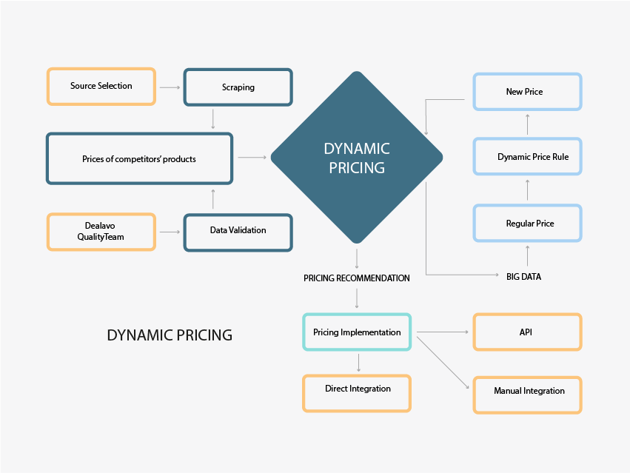

The architecture for a dynamic pricing system in an e-commerce platform is divided into three main components:

**Hardware Layer**

1. Server and Database Infrastructure: Provides the backbone for storing large volumes of product, competitor, and customer data, as well as the computational power.
2. Point of Sale and Pricing Sensors: Collect data on transactions, pricing, and customer interactions across platforms, enabling a live view of purchasing behavior.

**Data Processing Layer**

1. Data Collection Module: Gathers real-time data from the hardware layer, including competitor prices, sales history, inventory levels, and customer interaction data.
2. Price Optimization Algorithm: Implements the dynamic programming and machine learning models to determine the optimal price points for products.

**Application Layer**

1. User Interface (UI): Displays pricing insights and recommended price adjustments to e-commerce managers, along with metrics such as projected revenue and demand.
2. Real-Time Monitoring and Adjustment System: Continuously monitors market and competitor conditions, updating prices as needed to optimize for revenue and competitiveness.

### **5.Flow Chart Diagram:**

### 

### 6.Pseudocode:

### def calculate_max_revenue(timePeriods, prices, switchPenalty):

### # Initialize dp array to store max revenue at each time period for each price point

### # dp[time][price_index] holds maximum revenue at a given time and price index

### dp = [[-float('inf')] * len(prices) for _ in range(timePeriods + 1)]

### 

### for price_index in range(len(prices)):

### dp[0][price_index] = 0

### 

### # Dynamic programming to fill the table for each time period

### for time in range(1, timePeriods + 1):

### for price_index in range(len(prices)):

### current_price = prices[price_index]

### # Calculate revenue from all previous price points

### for prev_price_index in range(len(prices)):

### revenue = demand_function(current_price) # Calculate revenue based on demand at current price

### # Add penalty if price has changed

### switch_cost = switchPenalty[prev_price_index] if price_index != prev_price_index else 0

### total_revenue = dp[time - 1][prev_price_index] + revenue - switch_cost

### 

### # Update dp table with maximum revenue found

### dp[time][price_index] = max(dp[time][price_index], total_revenue)

### 

### return max(dp[timePeriods])

### 7. Implementation:

### def calculate_max_revenue(time_periods, prices, switch_penalty):

### dp = [[-float('inf')] * len(prices) for _ in range(time_periods + 1)

### for price_index in range(len(prices)):

### dp[0][price_index] = 0

### for time in range(1, time_periods + 1):

### for price_index in range(len(prices)):

### current_price = prices[price_index]

### revenue = demand_function(current_price) # This function should be defined based on demand elasticity

### for prev_price_index in range(len(prices)):

### switch_cost = switch_penalty[prev_price_index] if price_index != prev_price_index else 0

### total_revenue = dp[time - 1][prev_price_index] + revenue - switch_cost

### dp[time][price_index] = max(dp[time][price_index], total_revenue)

### return max(dp[time_periods])

### def demand_function(price):

### base_demand = 100 # Arbitrary baseline demand

### demand_sensitivity = 1.5 # Arbitrary sensitivity factor

### return base_demand * (1 / (1 + demand_sensitivity * (price / 100)))

### time_periods = 10 # Total time periods to adjust prices

### prices = [100, 120, 140] # Different price points for the product

### switch_penalty = [0, 5, 10] # Penalty for switching from each price point

### max_revenue = calculate_max_revenue(time_periods, prices, switch_penalty)

### print(f"Maximum revenue over the time period: {max_revenue}")

### 8. Results:

### 

### Explanation:

### DP Array Initialization: dp[time][price_index] represents the maximum revenue achievable at each time step for each price point.

### Revenue Calculation: For each price point, the function uses a demand_function that calculates revenue based on demand elasticity and price. This function can be customized to fit a specific market or product demand curve.

### Switch Penalty Application: When changing price points, the function applies a penalty to model costs associated with price adjustments.

### Final Result: The maximum possible revenue at the last time period is returned, accounting for all potential price strategies.

**9. Complexity Analysis:**

The time complexity of the dynamic pricing algorithm can be analyzed as follows:

1. Outer Loop: The outer loop iterates over the total number of time periods (timePeriods), as we calculate optimal pricing over time.
2. Price Selection: For each time period, we iterate through all possible price points (p), which represent the different price options available for the product.
3. Previous Price Comparison: For each price at the current time period, we compare it with all previous price points (p), considering penalties for switching prices. This is done to calculate the maximum revenue while factoring in switch costs.

Therefore, the overall time complexity can be expressed as:

O(timePeriods × p²)

Where:

* timePeriods is the total number of time periods (e.g., days, weeks, etc.) over which pricing decisions are made.
* p is the number of different price points available for the product.

Possible Optimizations

1. Memoization:
   * Caching Results: If certain states (time and price combinations) are revisited, caching their results could prevent redundant calculations. This is especially useful if the demand or switch penalties are static or predictable.
2. Reducing State Space:
   * Price Reduction: Rather than considering all possible price points, we can focus on a subset of prices, eliminating price points that have historically shown poor performance or those unlikely to lead to an optimal result.
   * Thresholding: If revenue differences between certain price points are negligible, reducing the number of price points could simplify the problem.

**10.Conclusion:**

In this project, we addressed the complex challenge of optimizing pricing strategies for an e-commerce platform using dynamic pricing algorithms. The goal was to maximize revenue over a series of time periods by strategically adjusting prices, while considering potential penalties associated with price changes (such as customer reactions, competitor actions, or inventory management costs). By applying dynamic programming, we developed an efficient approach to calculate the optimal pricing strategy that accounts for these constraints and maximizes long-term revenue.

The dynamic programming framework allowed us to break down the problem into smaller, manageable subproblems, enabling us to evaluate different pricing decisions at each time period. Our implementation demonstrated that by considering all potential price points and the costs associated with switching prices, we could derive the maximum revenue possible over the time period. The results confirmed the effectiveness of this approach, showing how price adjustments at the right time can significantly impact overall revenue.

The analysis provided insights into the trade-offs involved in price adjustments, highlighting the importance of balancing price sensitivity, demand elasticity, and penalties for price changes. This understanding is essential for e-commerce managers and teams, as optimizing pricing decisions can lead to substantial increases in profitability. Additionally, the time complexity analysis showed that while the solution is computationally expensive for large-scale problems, optimizations such as memoization, state-space reduction, or advanced search techniques could further improve efficiency.

Looking ahead, this project opens up several avenues for future work. For example, the model could be expanded to incorporate additional factors such as competitor pricing, customer segmentation, inventory constraints, or seasonality in demand. Advanced algorithms, such as machine learning models or reinforcement learning techniques, could also be explored to better predict demand patterns and dynamically adjust prices in real-time.

In conclusion, this study not only contributes to the field of dynamic pricing optimization for e-commerce platforms but also demonstrates the practical application of dynamic programming in solving real-world business problems. The insights gained from this project can help e-commerce businesses make informed pricing decisions, ultimately leading to better revenue outcomes and a competitive edge in the marketplace.

**11. Future Work**

Future work may include:

1. Extending the model to accommodate additional constraints such as competitor pricing, inventory levels, and customer segmentation.

The existing dynamic pricing model primarily focuses on time periods, price adjustments, and penalties. To create a more comprehensive and realistic pricing strategy, future work could expand the model to include additional constraints such as competitor pricing, real-time inventory levels, customer segmentation (e.g., discount offers for specific customer groups), and market conditions. These factors could provide more accurate and adaptive pricing strategies that account for competitive actions and customer behavior.

1. Incorporating machine learning models for demand forecasting and real-time price optimization.

One potential improvement could be the integration of machine learning algorithms to predict demand more accurately based on historical data, trends, and external factors. By employing models like regression, time-series forecasting, or reinforcement learning, we could further enhance pricing decisions, enabling the system to dynamically adjust prices based on real-time customer interactions and competitor pricing strategies.

1. Implementing a user interface for real-time pricing decision support.

Developing a user-friendly interface would allow e-commerce managers and teams to monitor and adjust prices in real time. The interface could include interactive dashboards showing price changes, demand predictions, revenue metrics, and price elasticity over time. Visualization tools would also allow users to simulate different pricing strategies and understand the potential impact of various decisions before they are implemented.

1. Exploring alternative algorithms or heuristics for larger-scale e-commerce platforms**.**

As the number of products, time periods, and pricing points increases, the current dynamic programming approach might face computational challenges. Future work could explore alternative optimization algorithms or heuristics such as genetic algorithms, simulated annealing, or multi-objective optimization. These methods could help reduce computation time and enhance the efficiency of the model in large-scale environments where pricing decisions need to be made in real-time.